33 Stats Video Lecture inference for comparing two independent means

1. using the distracted eaters experiment
2. how can we estimate the difference between the two different means?
   1. we need to find the point estimate and the margin of error. For differences, that is:
   2. 
   3. the standard error for differences is:
   4. 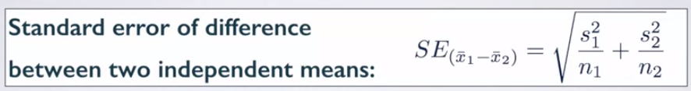
   5. The degrees of freedom is different too
   6. 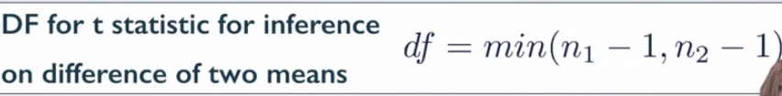
3. Conditions for difference
   1. are the observations independent?
      1. between groups
      2. within groups
   2. sample size, and skew
      1. if there is a large skew, the sample size needs to be large